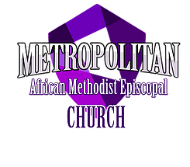

McZier Scholarship
Application and Instructions

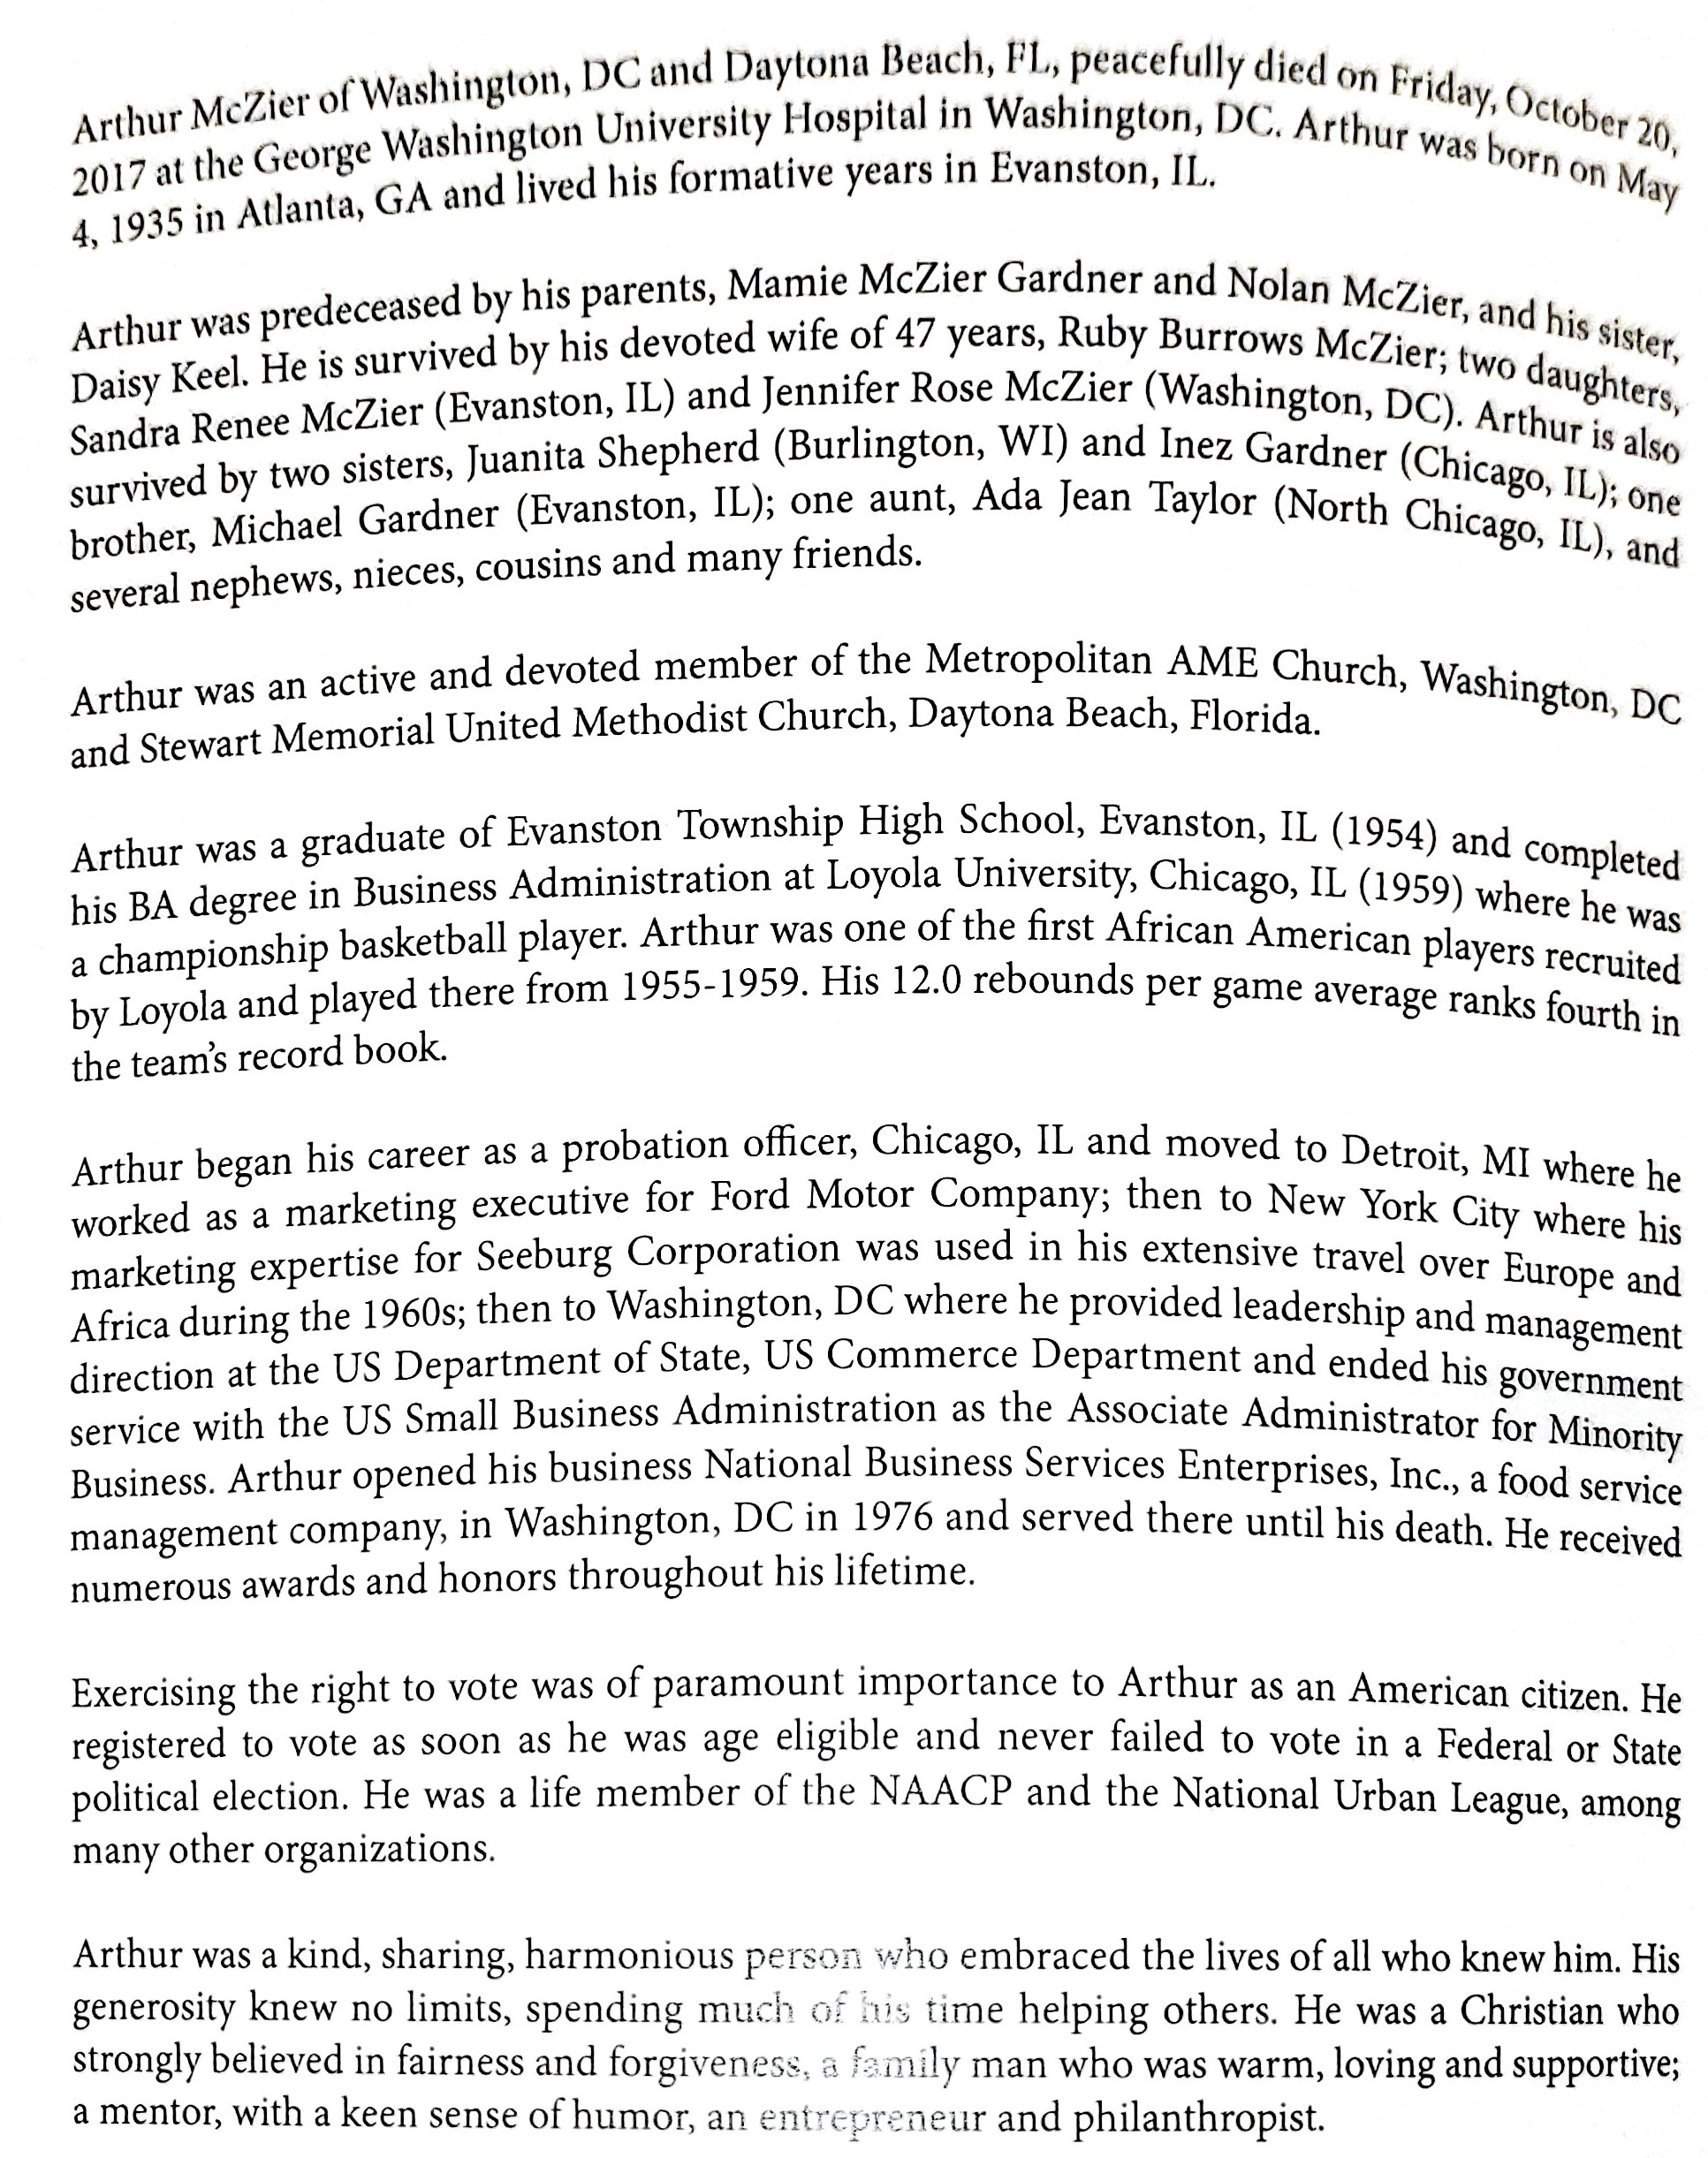
This scholarship is established to assist "C" students at Metropolitan A.M.E. to pursue opportunities in higher education.

Eligibility Criteria
Scholarship awards are available for students who meet the following criteria:
- Current members in good standing of Metropolitan African Methodist Episcopal Church
- Cumulative grade point average of C
- Resident of the District of Columbia
- Proof of enrollment or acceptance in an accredited post-secondary institution.
- Submit all required application materials online at scholarships@metropolitanamec.org and comply with all application requirements within the prescribed time period of March 15 to May 1.
  - All materials must be received by May1.
  - Incomplete applications will not be considered.
  - Application are to be submitted online
- Submit to the competitive application process administered by the Scholarship Committee
Types of Scholarship Awards and Disbursement
- The recipient may designate the scholarship award for tuition aid and/or books. All checks will be payable to the post-secondary institution. The amounts of awards vary from year to year.
- The Scholarship Committee will announce the awards by May 30 and presentation of awards will take place on the second Sunday in June as part of the Youth Day celebration at Metropolitan A.M.E. Church during the 11:00 a.m. worship service.
- The recipient, or an immediate family member, is requested to attend this service to receive the acknowledgement of the award.
APPLICATION FORM
Instructions:
- Each applicant must submit a completed application online to the Scholarship Committee.
- Applications and all supporting material will be accepted beginning March 15 but must be received by May 1.
- Incomplete materials will not be considered. Read the application carefully and answer all questions. In addition, submit the following information:
  - Letter of acceptance or a current certificate of enrollment (if currently enrolled) to an accredited post-secondary institution.
  - Letter of recommendation from one of the following:
    - a counselor or major academic advisor.
    - Letter of recommendation from one subject instructor.
  - Transcript or record of grades verifying a cumulative grade point average of C
  - A personal statement written by applicant addressing academic merit, reasons for pursuing vocational and occupational goals, and why deserving of an award (not to exceed 150 words).
  - Any other pertinent information, i.e., honors, awards, special programs.
  - Interview: Each qualifying applicant will be required to appear before the Scholarship Committee for a personal interview.
    - Failure to appear for the scheduled interview will result in disqualification of the application.
- Please submit application and supporting documents online to scholarships@metropolitanamec.org.

Any scholarship applications and documents that are not received by the deadline will not be considered.

1. Name _____________________________________________________________________
(Last) (First) (Middle)
A. Present Address_____________________________________________________________
B. Home Address ______________________________________________________________
C. Phone ( ____ ) _________ ______ ( ______ ) ______________________
(Day/Home) (Evening/Cell)
D. Email Address ______________________________________________________________
2. What is your career goal? ______________________________________________________
3. Are you a member of Metropolitan A.M.E. Church? _______
4. State the church activities in which you participate (e.g, Sunday School, clubs, choirs):
______________________________________________________________________________
___________________________________________________________________ _________
5. Name of High School __________________________________________________________
Address _________________________________________________________________ _____
Date of graduation/expected graduation ___________________________________________
6. Name of post-secondary institution where you are seeking enrollment:
_____ _________________________
Address __________________ __________________________________________________
If accepted, anticipated date of enrollment _________________________________________
7. What is your proposed major field of study? ___________________________________________________
8. Do you or will you attend school full time or part time? __________________________________________________
9. Indicate number of credit hours ___________________
10. Name and address of the counselor or major academic advisor who will submit a letter of recommendation:
_____________________________________________________________________________

11. What is your cumulative grade point average? Numerical ___________ Letter ___________
What scale is your grade point calculated on? ________________________________________
12. When do you expect to complete your course work? ________________________________
13. List all high school or post-secondary extracurricular activities and offices held:
______________________________________________________________________________
___________________________________________________________________ __________
14. List all volunteer and community work performed:
______________________________ _________________________________________
I, _________________________________________________ , hereby certify that the information* submitted in this application is true and correct.
I, _________________________________________ , hereby certify that I am a current member of Metropolitan A.M.E. Church
__________________________ __________________________________________________
(Date) (Signature)
I, _________________________________________ , hereby certify that I am a current member of Metropolitan

(Date) (Signature)

